My Project
Final Project Definition Template

By:
Student 1 Yoav Zinger
Student 2 Arad Gonen
Student 3 Mariel Borodkin

Supervisor:
Yaniv

Git:
aradgonen/OpenShift-Sentinel: Cyber Course Project - SIEM (github.com)

Table of Contents
1. Project description 3
2. Related Work 3
3. Functional Description / Requirements 3
4. Architecture 3
4.1. Each Module description 4
5. Work plan 4
6. Client side 5
6.1. Usage Illustration 5
6.2. Mockup 5
7. Server Side 5
7.1. API 5

Project description

Tool for the compliance framework. The tool is used to deploy compliance policies onto OpenShift clusters and monitor the policies results. The tool is used by compliance officers in organizations to enforce and visualize compliance status on OpenShift clusters.

Related Work

Our work related to an Open Source project which eventually supposed to join Red Hat's official Open Source repo:
https://github.com/openshift-4-compliance/openshift-4-compliance-automation
Our project is supposed to deliver a deployment strategy for our tool, including automatic connector to cluster's logs.

- Sync Controller - Used to sync policies from a git repository with the UI. A user can choose to deploy policies from the specified Git repository (as described in the diagram).
- Frontend - Allows the user to deploy policies via a wizard that syncs with the sync controller for policy deployment.
- Policy Controller - Used to receive data from the user & frontend, and deploy the policies via the specified tool
  - Red Hat Advanced Cluster Management for Kubernetes
Open Policy Agent Gatekeeper

Functional Description / Requirements

- Collect data at scale and detect based on Openshift audit and security logs for security information event management (SIEM) solution.
- Investigate and respond to incidents rapidly – Provide security orchestration automated response (SOAR) solution of specified tasks.

Architecture

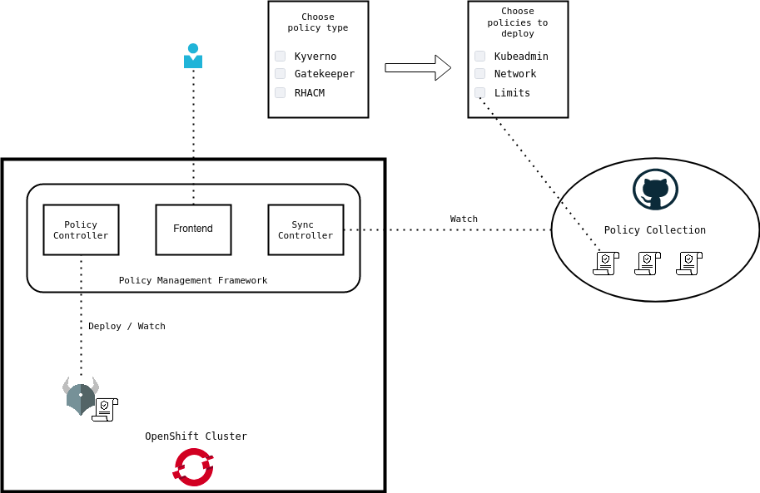

Each Module description
In this sub section you will describe the responsibility of each module… in case the module is a combination of several sub modules you should drill down and describe each of this sub modules as well.

Work plan

This section will present the work plan of the project, the work plan must include milestone and responsibility of team members

Mariel Borodkin – Overall cybersecurity design and planning, DevOps
Arad Gonan – SIEM FE, SOAR functionality
Yoav – BE, custom policies

29/10/21 – Choose idea, meet with RedHat for collaboration
14/11/21 – Idea and work agreement established for Open Source (OSS) project.
14/11/21 - Project Idea was approved by supervisor.
28/11/21 - Deploy Dev environment for research test purposes of the technology.
14/12/22 – POC succeed.
28/12/22 – First security custom policy deployed for monitoring on Dev environment.
07/01/22 – HLD design architecture, plan components, choose technology solutions.
14/02/22 – Basic client - server side for visualization of OpenShift logs (SIEM)
14/02/22 – Basic client - server side for visualization of OpenShift logs (SIEM)
21/02/22 – Basic SOAR functions resolving policy security threats.
01/03/22 – Own custom policy for Database authentication security.
10/03/22 – Custom PatternFly components is ready to used.
13/03/22 – Authenticate to app via SSO (Optional to client's preference)
16/03/22 – Add login functionality to SIEM using RedHat SSO.
21/03/22 – Admin page and management pane to SIEM.
05/04/22 – Basic GraphQL schemes is functioning and UI in pooling using GraphQL/Appolo client.
05/04/22 – ElasticSearch instance is up and used for OpenShift audit log forwarding.
07/04/22 – Frontend is ready to visualize two types of graphs.
21/04/22 – SIEM is done – both backend and frontend.
01/05/22 – Basic SOAR functionality is deployed in Sentinel backend.
08/05/22 – All OpenShift-Compliance policies is deployed on the Dev cluster.
10/05/22 – SIEM is monitoring all compliance policies.

Client side

In projects that include a client side – and app or website need to fill in this section.
This section describe the look and operation of the client UI:

Based on React, using patternfly UI framework. For example:

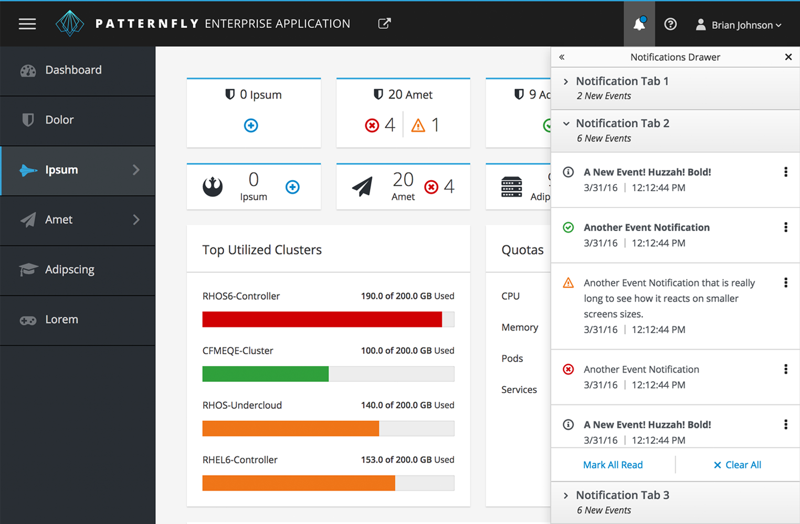

Usage Illustration
User will deploy our application with automation deployment strategy on a node in OpenShift environment. Policies will be deployed as YAML files:
oc apply -f policy.yaml

Mockup
This is an illustration, not our app:
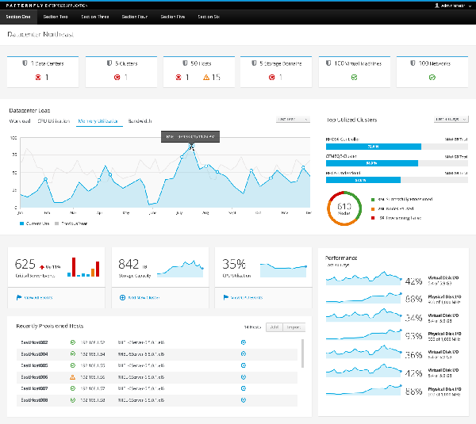
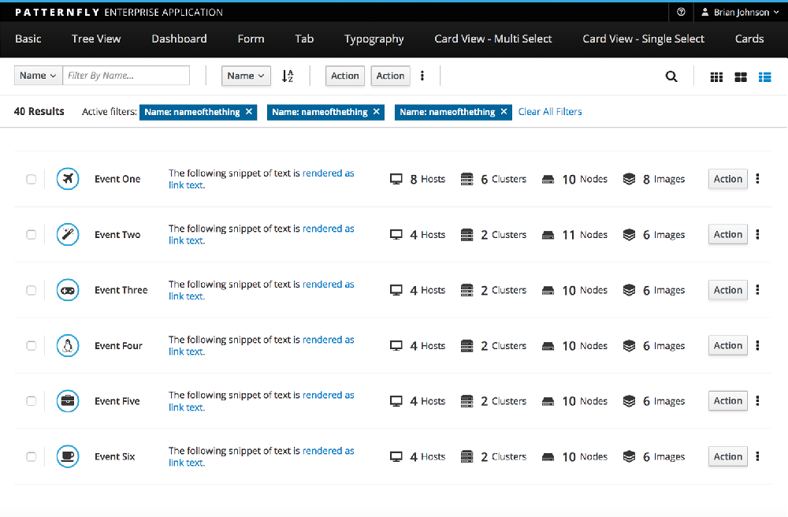
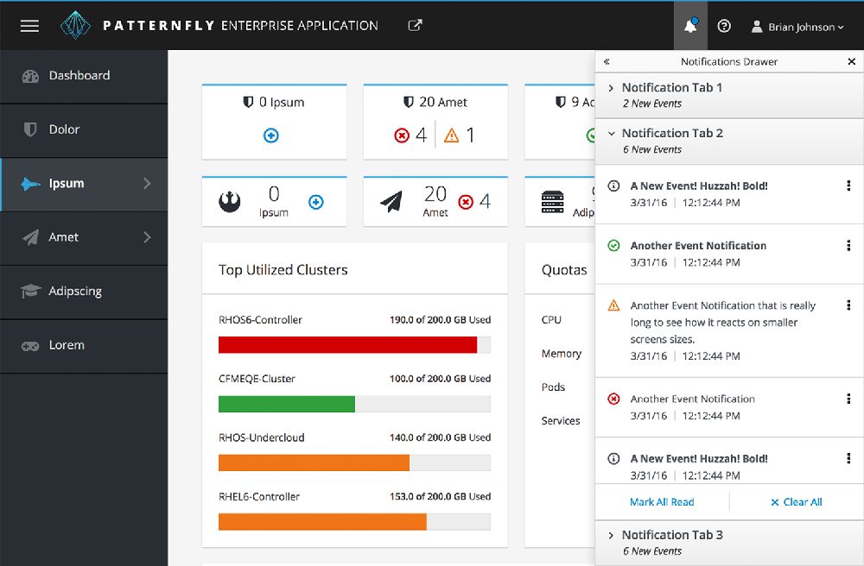
Source: PatternFly | open interface project

Server Side
Based on NodeJS BE with MongoDB Database. Using Reddis as cache.

API
Exposing API that checks for CVEs for policy exploits in exploit-DB
Exploit Database - Exploits for Penetration Testers, Researchers, and Ethical Hackers (exploit-db.com)
Before deploy a YAML.

